LAB Logbook
Lab 1
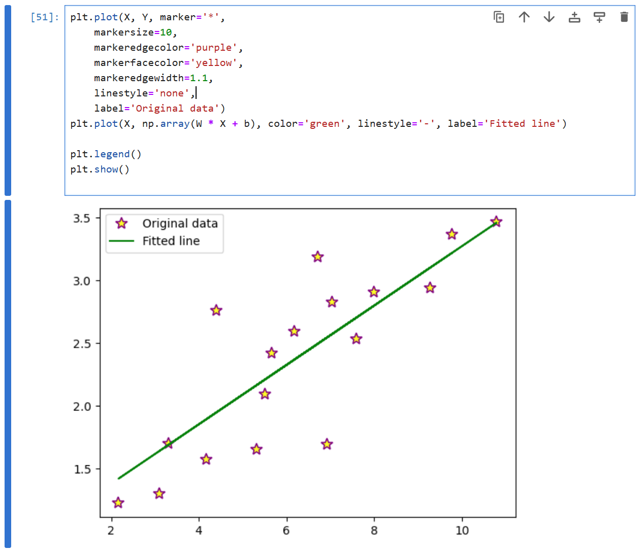
Lab 2
1.
Training Accuracy: 0.97
Test Accuracy: 0.94
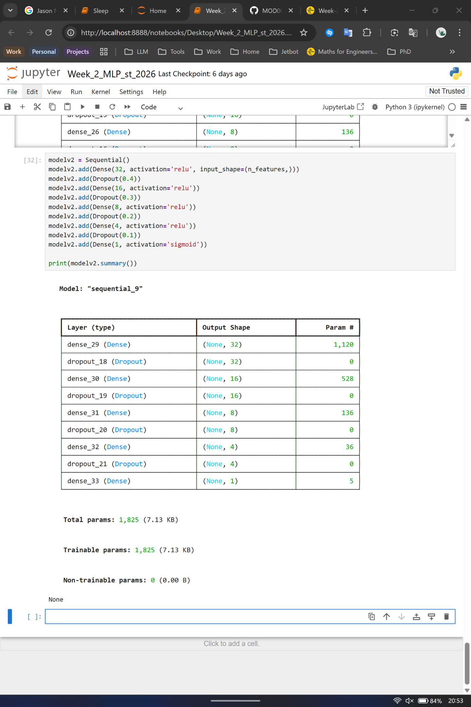
2.
3.
O1: 1.808
O2: 1.808
Lab 3
Training Accuracy: 0.99
Test Accuracy: 0.89
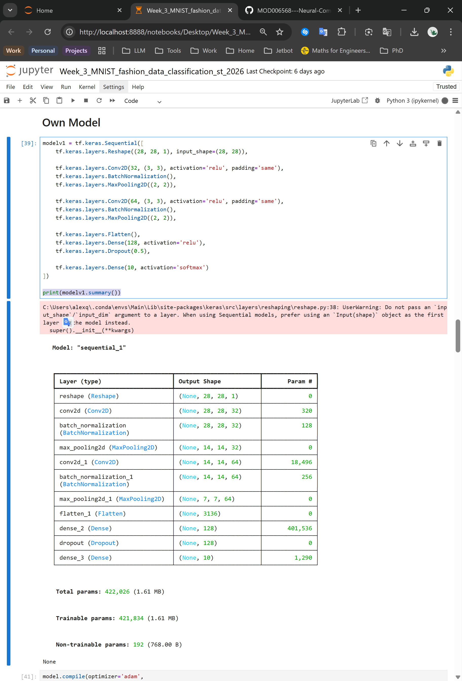
Lab 4

Lab 5

Lab 6

Lab 7

Lab 8

Lab 9

Lab 10

Lab 11

Lab 12

